Lab Work Assignment 2:

Save and submit your SQL queries for each skill check, in a text file or in MS Word and attach them to this assignment. Be sure to name the file, f_lastname_Week3.doc so I can keep the files straight. Thanks.

This is the 2nd assignment due by Monday, Feb 16, 2015, 18:00, PST. No late assignments will be accepted. The assignment is worth 5 points. This is the second of a total of 4 assignments, for a total of 20 points.

Lab 6.1: Top N Queries Skill Checks 1 to 4

Lab Prep: Before you can begin the lab you must run the (SQLQueries2012Vol2Chapter6.1Setup.sql) script to reset the database.

Please make sure to close all query windows within SSMS.

Skill Check 1: In the JProCo database, create the SQL syntax to display only the two EmpID records with the oldest HireDate in the Employee table. When done, the result set should resemble the one shown below.

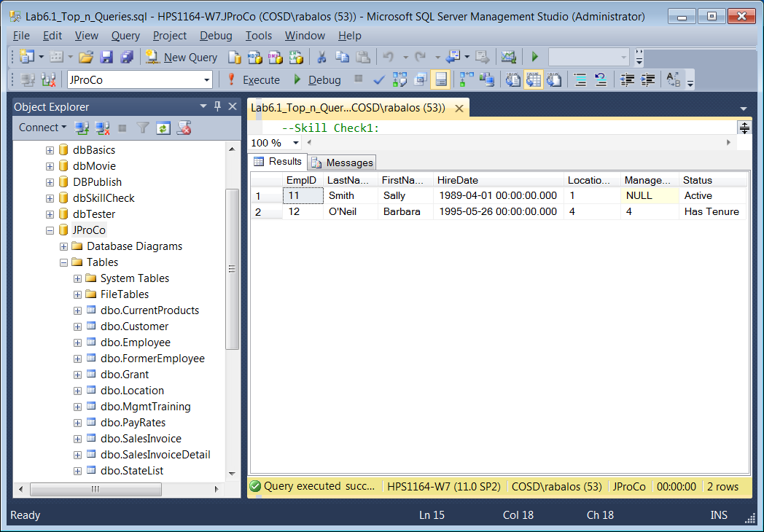

Skill Check 2: In the JProCo database, display the six largest grants found in the Grant table. Make sure any tied values will also appear in the result set. When done , the result set should resemble the one shown below.

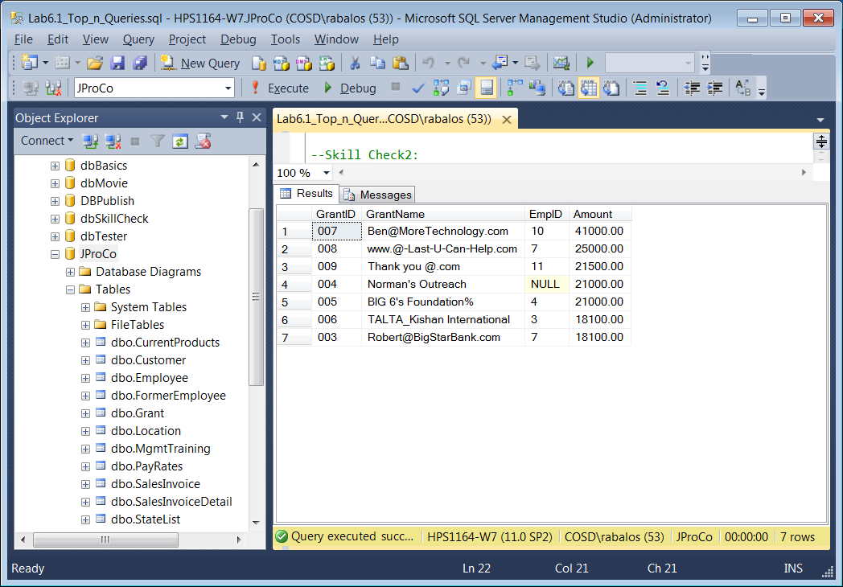

Skill Check 3: In the JProCo database, display the ten most expensive single day trips found in the CurrentProducts table. Since an overnight stay is not required, a day trip has a value of No-Stay in the Category field. When done, the results should resemble those shown below.

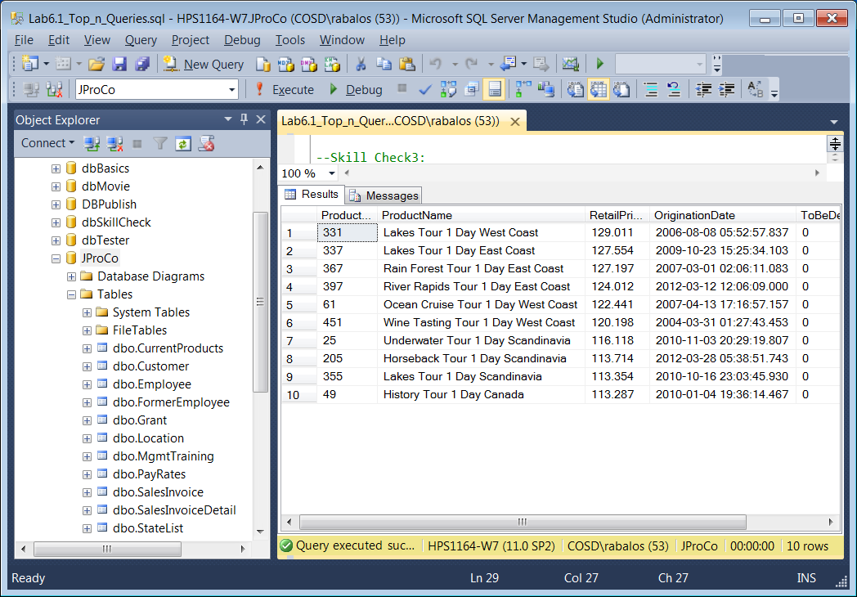

Skill Check 4: Our sister company is now handling all trips lasting two weeks and thus need to be deleted from our CurrentProducts table. There are 81 records in the CurrentProducts table marked ToBeDeleted with a value of one (1). Create and run a query to delete the **first** **10** records in the CurrentProducts table. Once this is complete, create and run a another query to verify there are only **71** ToBeDeleted records with a value of one (1) remaining in the CurrentProducts table as shown below.

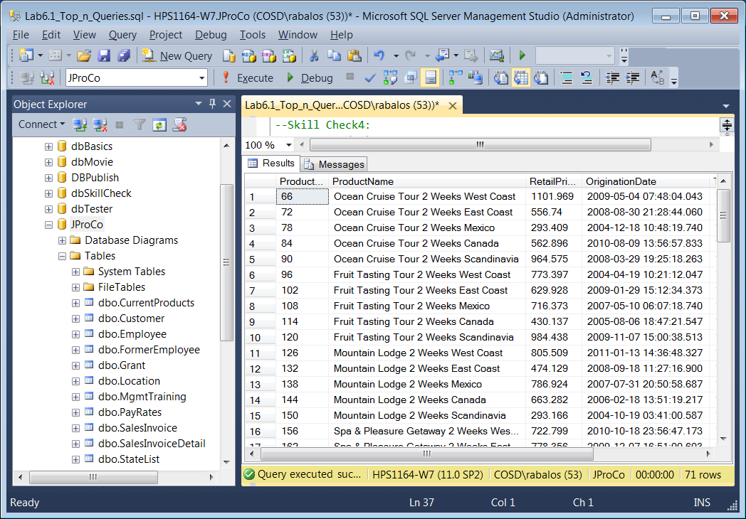

Lab 6.2: Top N Tricks Skill Checks 1 and 2

Lab Prep: Please run the (SQLQueries2012Vol2Chapter6.2Setup.sql), before running the lab setup script to reset the database

Skill Check 1: In the JProCo database, write a query to find and then display only the third most expensive record from the Grant table based on the Amount field.

Hint: Locate the most expensive single GrantID that is not in the TOP( 2) results. When done the results should resemble those shown below.

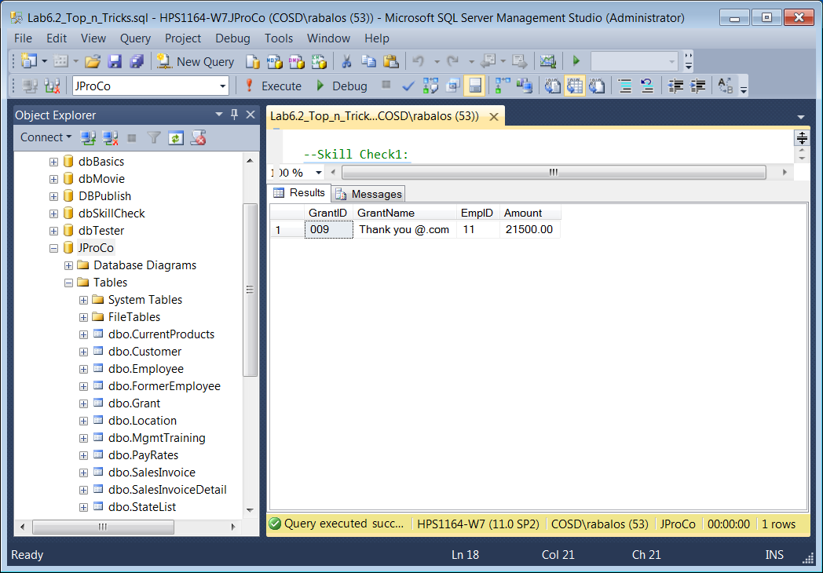

Skill Check 2: In the JProCo database context, write a query to find the three newest employees from the Employee table with a LocationID of 1. When done, the results should resemble those shown below.

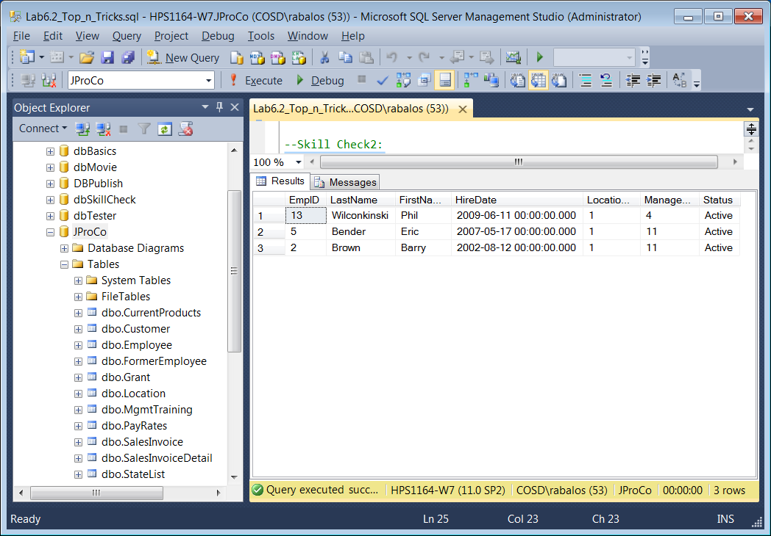

Lab 6.3: Top(n) Percent

Lab Prep: Before you can begin the lab you must run the script (SQLQueries2012Vol2Chapter6.3Setup.sql) to reset the database.

Skill Check 1: From the Employee table of the JProCo database, show the top 50% most senior employees by HireDate as shown below.

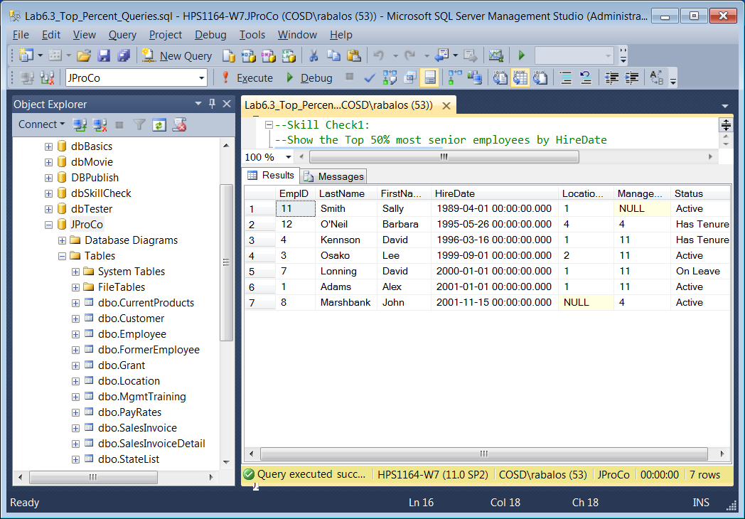

Lab 9.1: Union and Union All Skill Checks 1 and 2.

Lab Prep: Before you can begin the lab you must run the script (SQLQueries2012Vol2Chapter9.1Setup.sql) to reset the database.

Skill Check 1: The Grant table lists all grants, and vNonEmployeeGrants shows grants that were not found by an employee. The figure below shows these two result sets run at the same time. We can see they both include Norman’s Outreach. This is an example of two different sets of data with similar metadata (in this case the metadata is the same).

Write a query to combine the records from both tables. Since Norman’s Outreach is found in both tables, it should appear in the result set twice. Use the correct set operator to achieve this result.

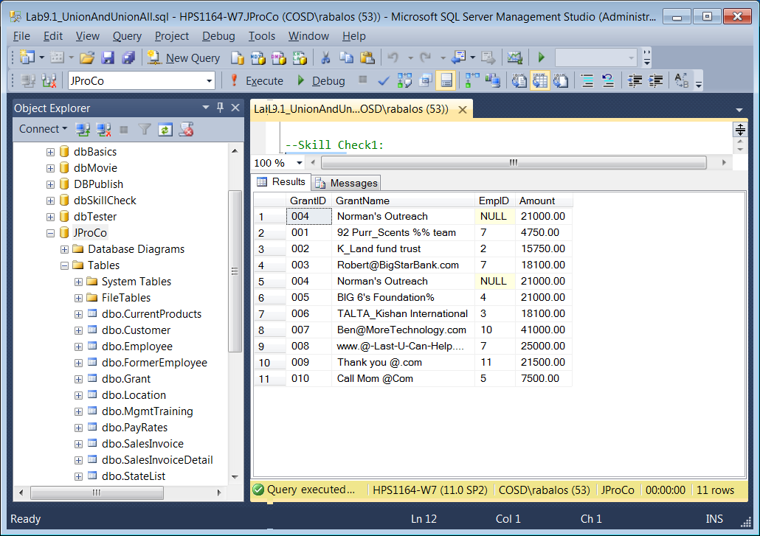

Skill Check 2: You have two employees whose status shows they have received tenure. You also have two employees who work in Location 4. You have one employee working in Location 4 who has received tenure. Write two separate queries from the Employee table to find each group of employees. Then use the correct operator to put both result sets into one and show the distinct employees. When you are done, your result should resemble the figure below.

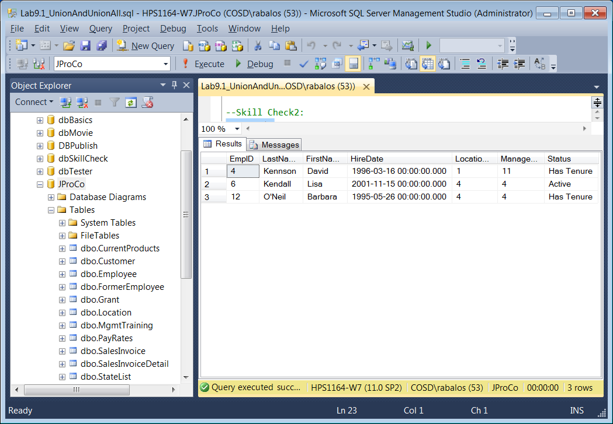

Lab 9.2: Intersect and Except Skill Check 1

Lab Prep: Before you can begin the lab you must run the script (SQLQueries2012Vol2Chapter9.2Setup.sql).

Skill Check 1: There are 81 records in your CurrentProducts table that are marked for deletion. Those products are to be moved to the RetiredProducts table. When you query the RetiredProducts table, notice there are only 75 records. Use the correct set operator to find the six ToBeDeleted records from the CurrentProducts table that do not appear in the RetiredProducts table.

When you are done, your result should resemble the figure below.

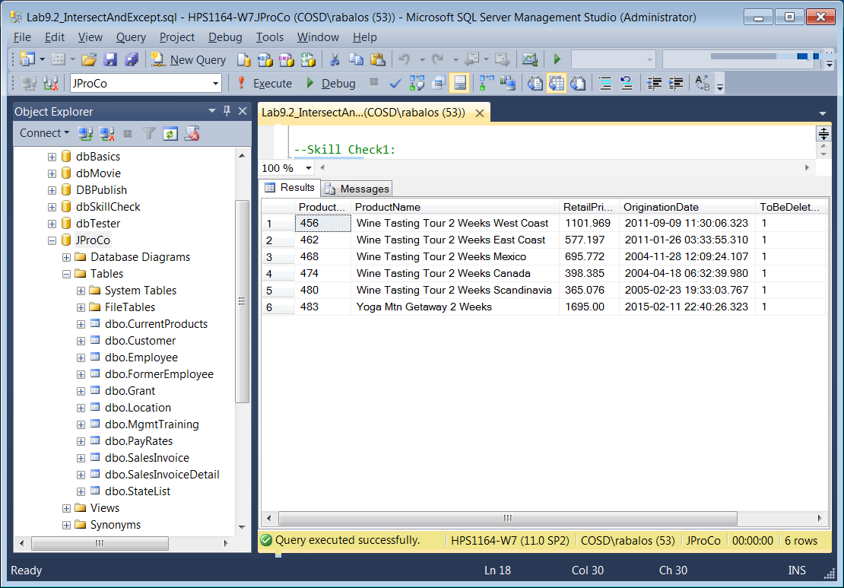

Lab 10.1: Common Table Expressions Skill Check 1.

Lab Prep: Before you can begin the lab you must run the script (SQLQueries2012Vol2Chapter10.1Setup.sql).

Skill Check 1: You want to create an external report of your locations with a CTE called LocList. This list should show all fields of the Location table except for LocationID. The fields should also get new names, as shown in the following matrix. o Street should be shown as Address o City should be shown as Municipality o State should be shown as Region When you’re done , your result will resemble the figure below.

